|  |
| --- |
| Circle Language Spec: Commands |

## Parameters in an Active Clause in a Diagram

This article demonstrates a situation of command objects.

This article illustrates how parameters in an active clause look in a diagram.

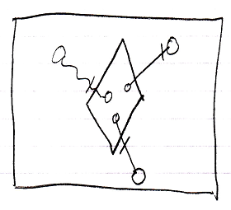

The large square is a command definition the inactive clause is in. The diamond inside the square is the active clause. The diamond contains three circles, which are the parameters in the clause. The circles inside the diamond are connected to the circles outside the diamond with parameter passings. Parameter passings are explained in the *Parameters* articles.